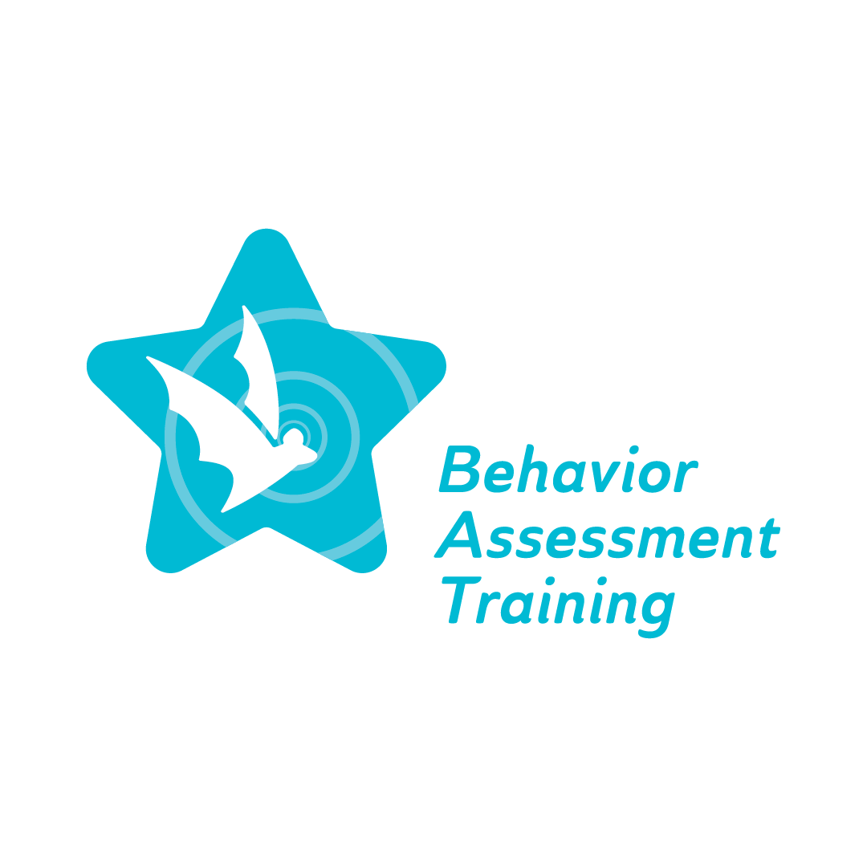
Fall 2022 Conference, Day 1, Session 2: Topic #1 Overview: Implicit Bias
Frequently Asked Questions (FAQ)

- How do teachers demonstrate cultural responsivity?
Be more aware and understand differences in culture and related characteristics including linguistics when working when diverse students. Be aware of cultural sensitivity. Create a classroom environment and instructional practices where students can add their input and knowledge of their background.
- How can we, as educators, realize that we are unintentionally stereotyping/biased against students with colors that lead to punitive school discipline and associated negative outcomes?
Teachers must realize their biases and overcome them when working with students of color. According to the article “The persistent effect of race and the promise of alternatives to suspension in school discipline outcomes,” the author states that educators often view African American students as more aggressive, and it often affects the administrative decisions to disproportionally expel or suspend out-of-school. When compared to White students, whom the teacher perceives to appear “less aggressive” and engaging in the same infraction receives less punishment. The inconsistency of consequences between these decisions affects both students of color and white students.
Anyon, Y., Jenson, J. M., Altschul, I., Farrar, J., McQueen, J., Greer, E., ... & Simmons, J. (2014). The persistent effect of race and the promise of alternatives to suspension in school discipline outcomes. Children and Youth Services Review, 44, 379-386.

