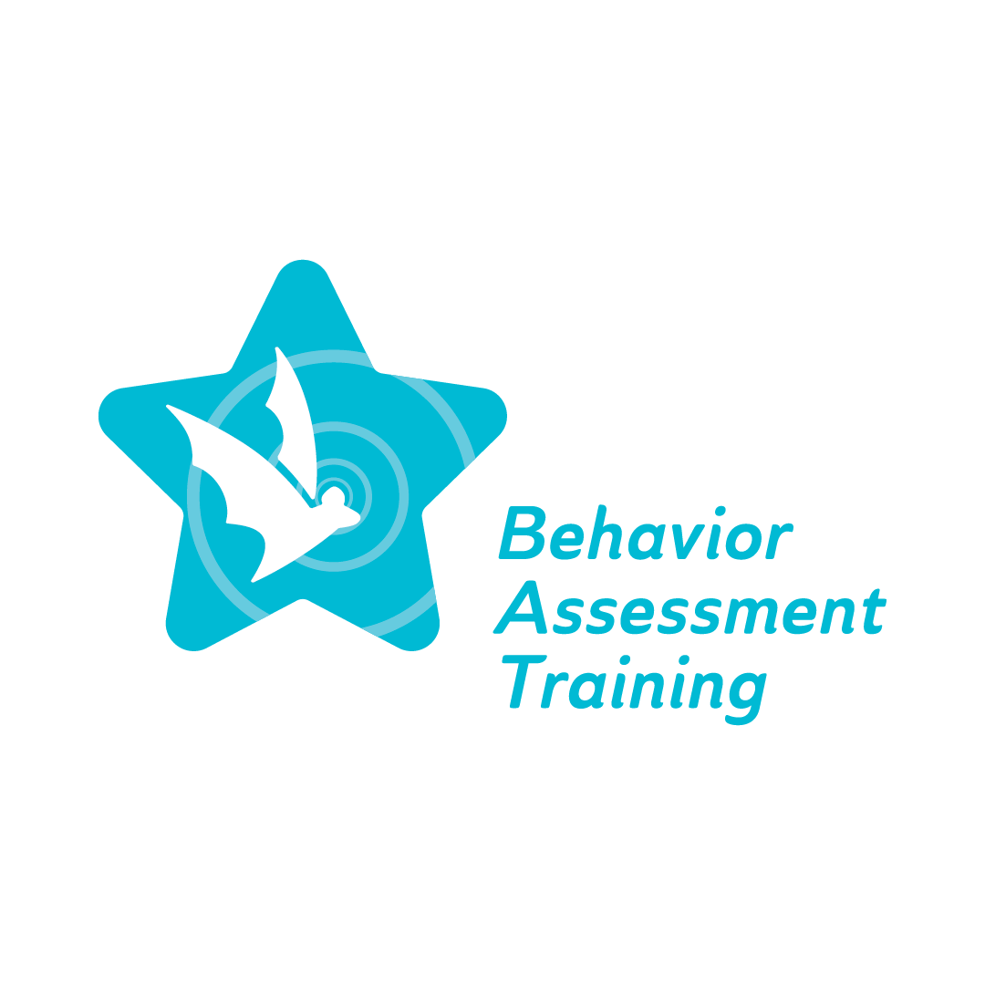
Topic 3: Restorative Practice: Building a Restorative Leadership Vision through Challenging Times
Frequently Asked Questions (FAQ)

Topic 3: Restorative Practice: Building a Restorative Practice leadership Vision through a Challenging Time

- What are the most prominent issues when it comes to restorative justice practitioners?
- Getting acquainted with building understanding and trust is one of the keys to success as a restorative justice practitioner. Some strategies could be building relationships by learning the students' names, pronouncing them correctly, letting them know how you want to be addressed, utilizing a preference survey to assess your student’s preferences, etc. After building the relationship, we can build trust by introducing who we are and what we are passionate about using storytelling.
- Addressing issues and visions would be the second step in being successful as a restorative justice practitioner. We can start introducing the school's mission and vision to educate and instruct children academically and socially.
- Developing a plan of action is the last step: developing a way to move forward to create a space where young people can feel safe enough to share their truth and validate it.
- What to consider when working with children and young adults as restorative practitioners?
  - Be able to understand that our population might have many issues regardless of their family history and traumatizing events that happened in their life.
  - Be mindful of that when working with everyone; it is the key to help them build the skills to succeed in school and may generalize it to their daily life.
  - Ensure that we are not deciding for them, but instead, we are guiding them and providing them with the skills and the resources to help make the decisions that are not based on emotion at that moment that might harm them, their peers, or the school community.
  - Understanding that failure is part of the process, and the key is not giving up. Whenever a mistake is made by the individual, instead of using verbal reprimands, listen and share what you think they could do better next time, but also let them handle the consequences of their mistakes.
- What are the best practices for a Restorative Culture and Climate?
  - According to Project Achieve's Behavioral Matrix. Best Practices that have been used to promote Progressive Disciplines:
- Students in the school should experience four positive interactions (collective, from adults, peers, or themselves) for every negative interaction (4:1).
- Students are primarily motivated through positive, proactive, and incentive-oriented means.
- When consequences are necessary, the mildest possible consequence needed to motivate students' appropriate behavior is used.
- Consequences, not punishment, are used.
- When consequences are over, students must still practice the previously expected pro-social behavior at least three times under simulated conditions.
- Staff must differentiate and respond strategically to skill-deficit versus performance-deficit students.
- Staff must recognize that incentives and consequences must remain stable because previous inconsistencies may have strengthened some students' inappropriate behavior.
- What are some Restorative Systems in Schools?
  - Creation of the position of Culture and Climate Coordinator
  - Peace room
  - Restorative conferences
  - Family group conference
  - Circles
  - Peer Ambassador
  - Boys town Education
  - Model (Coach and Support of Teachers) S.E.L. Curriculum
- What have you noticed that works for students who repeat the same offense?
  - Often it is due to academic deficits. Students may use their problematic behavior to get them out of their class, often called an escape function. The strategies to tackle these issues are:
    - Having a conversation with the child and learning different things about why they do what they do.
    - Checking their attendance at school.
    - Having a conversation with the related person, for instance, their peers and teacher(s).
- Each school might have something called "Supported Hours/Class," where the teacher would check in with their assigned class and discuss attendance, student grades, and class performance.
  - Teamwork is critical. Try to connect with everyone surrounding the student.
- What are the functions of behaviors?
  - Escape: Social negative reinforcement in the form of escape/ avoidance from demands
  - Attention: Social positive reinforcement in the form of attention
  - Automatic: Automatic reinforcement in the form of sensory stimulation or pain relief
  - Tangible/ Activity: Social positive reinforcement in the form of access (to materials, activities, persons, or food.)

