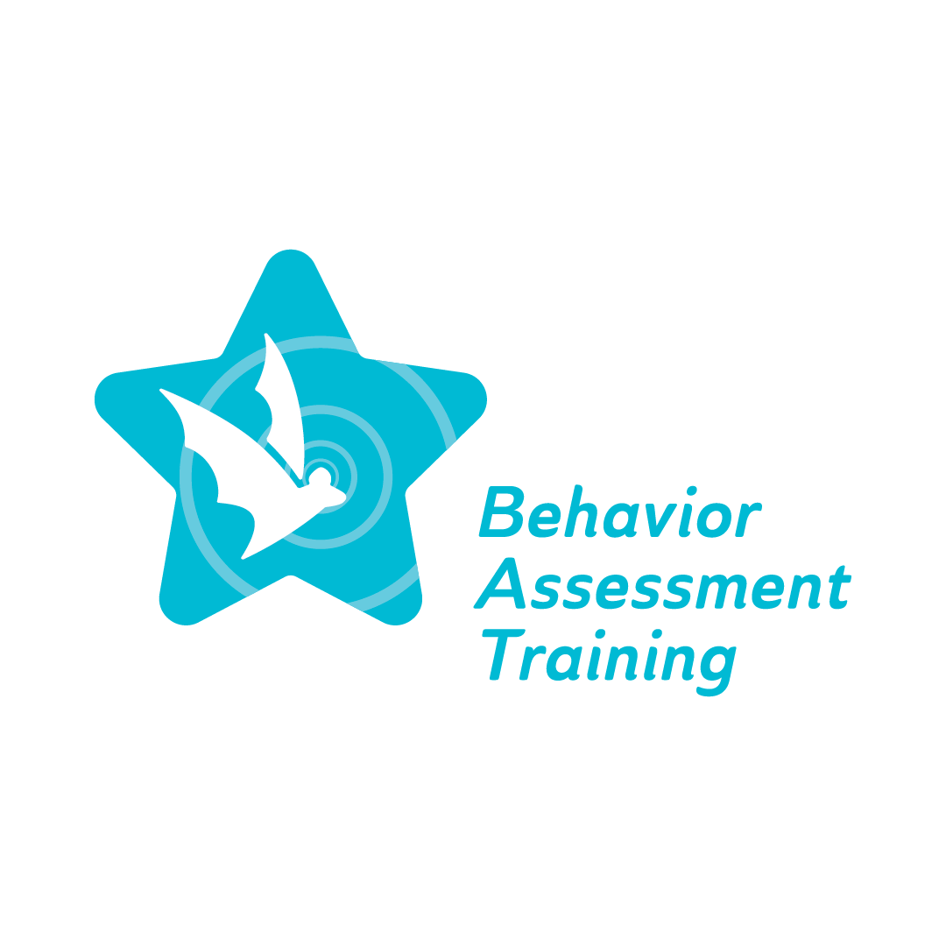
Topic 3: Restorative Practice: Building a Restorative Leadership Vision through Challenging Times
Glossary
Topic 3: Restorative Practice: Building a Restorative Practice leadership Vision through a Challenging Time

Multi-Tiered System of Support (MTSS): It is a framework to enhance the implementation of evidence-based practices to achieve meaningful outcomes for every student.

Restorative Justice: Restorative justice in schools is commonly referred to as restorative practices. It is a method of handling discipline and conflicts that prioritizes mending the harm caused by wrongdoing rather than solely penalizing the wrongdoer. It is based on the belief that when one person inflicts harm on another, it's crucial to attend to the needs of all involved parties, including the victim, the offender, and the wider community. This approach is an alternative to traditional punitive actions such as suspension or expulsion, which often fail to address the underlying issues and may even perpetuate a cycle of misconduct. Restorative justice endeavors to establish a more supportive and inclusive school environment by concentrating on repairing relationships and fostering a sense of community.

School Climate: It refers to the overall atmosphere, including the students' and staff's physical and emotional safety.

School Culture: It encompasses the school community's shared values, beliefs, and practices. It is what we want to practice, promote, and permit. It is not easy to see and understand the school culture because what we see is just language, folklore, fine arts, food, or festivals. What is hard to see is family roles, cultures, family values, gender roles, interpretations, etc.

Zero Tolerance: Zero-tolerance policies require school officials to hand down specific, consistent, and harsh punishment—usually suspension or expulsion—when students break specific rules.

