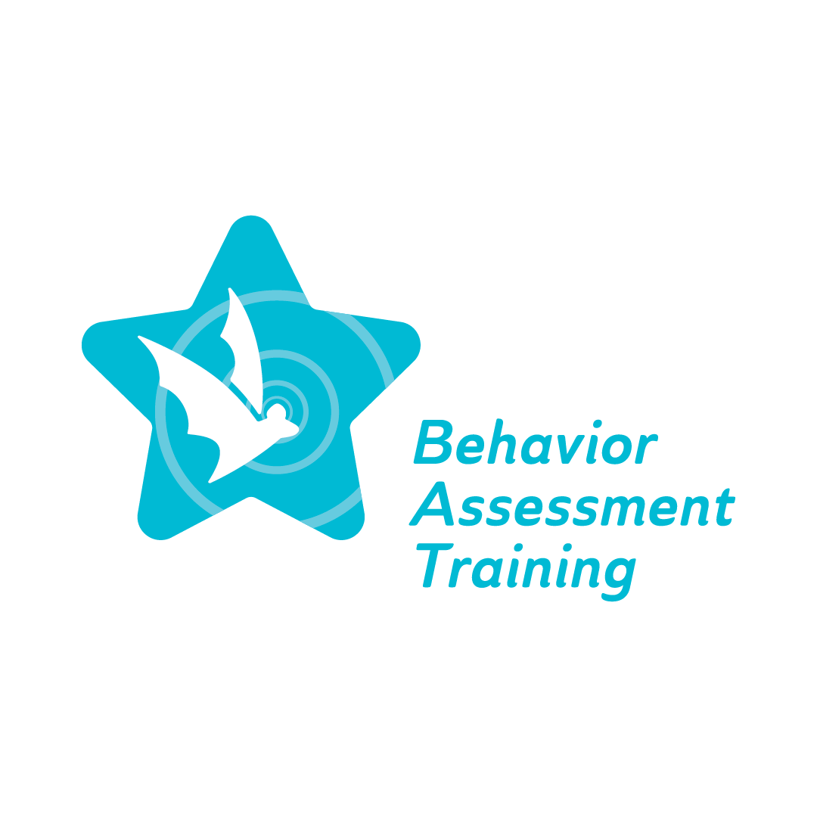
Topic 1, Part 2: Evaluating Our Own bias:
Viewing student behavior through a contextual lens
Frequently Asked Questions (FAQ)
- What are the 13 categories of IDEA?
- Autism
- Deaf-Blindness
- Deafness
- Emotional Disturbance
- Hearing Impairment
- Intellectual Disability
- Multiple Disabilities
- Orthopedic Impairment
- Other Health impairment
- Specific Learning Disability
- Speech Language Impairment
- Traumatic Brain Injury
- Visual Impairment
2. What are evidence-based behavior interventions?
It is research-based interventions that have been proven effective when working with challenging targeted behavior.
3. How do you recognize your own biases?
- DO NOT assume
- Reflecting on your stereotypes, prejudices, and discrimination
- Acknowledge that everyone will have biases and educate ourselves surrounding the topics
- Embrace and be willing to learn diverse perspectives

4. How do assumptions impact student learning?
School professionals may have assumptions about student learning, behaviors and their capability for academic success which are tied to students’ identities and/or backgrounds. Instructors’ assumptions may impact student learning by setting lower expectations for students from a different background.
Staats C et al. (2017). State of the Science: Implicit Bias Review 2017. Kirwan Institute for the Study of Race and Ethnicity.

