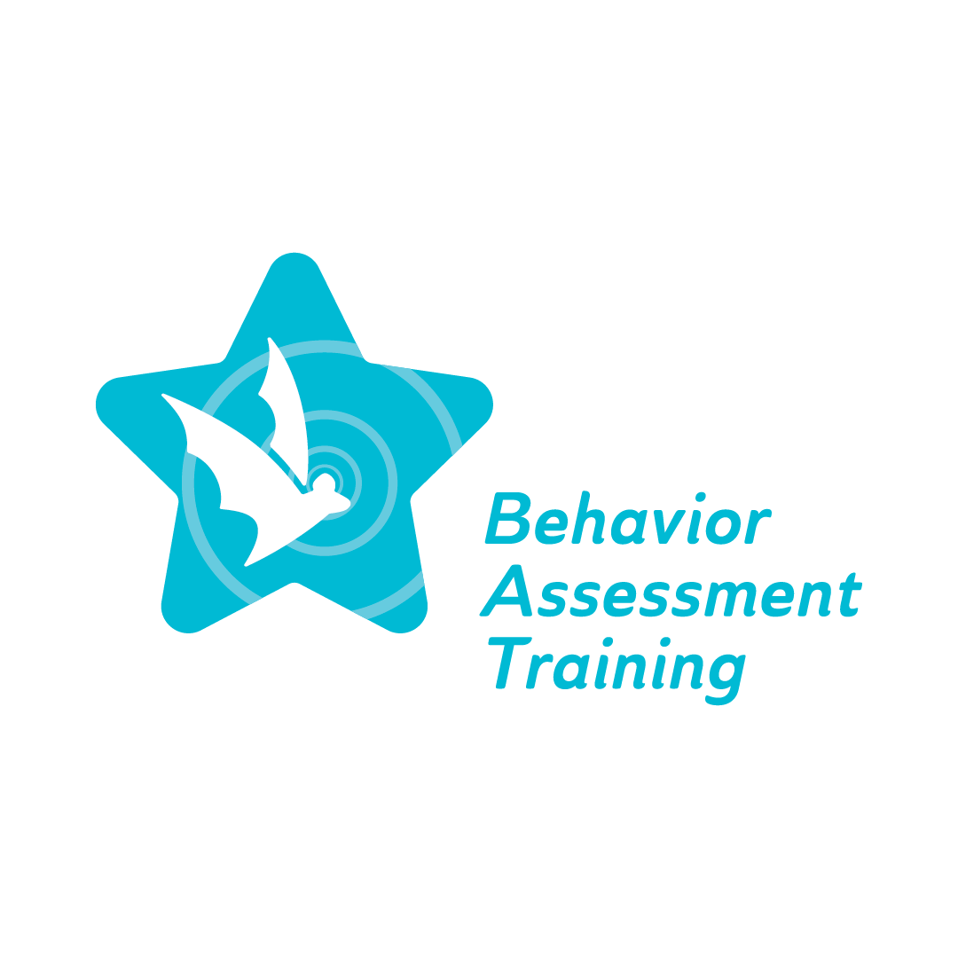
Topic 1, Part 3: Legal and Ethical Requirements of FBAs and BIPs:
Viewing student behavior through a professional lens
Frequently Asked Questions (FAQ)
- What are some of the legal requirements regarding FBAs and BIPs listed under the Individuals with Disabilities Education Act (IDEA)?
A functional behavior assessment (FBA) must be conducted when the IEP team decides more information is required to understand a student’s needs relating to their behavior. If a student with an IEP is suspended for more than 10 consecutive school days, the IEP team is mandated to complete an FBA. The team must meet to plan out the FBA and BIP within 10 school days of the first day of suspension. The IEP team also might decide to go through with a disciplinary change of placement for this individual student. In this case, an FBA is not a requirement, although it is recommended.
A behavior intervention plan (BIP) should incorporate positive behavioral strategies, as well as supplementary aids, services, and supports that address the individual student’s positive and negative behaviors. The BIP must address the function of the student’s behavior and replace it with more appropriate behaviors.
- What kind of assessments should members of the IEP team utilize in writing FBAs and BIPs?
Direct and indirect assessments must be used to assist the team in writing FBAs and BIPs. Direct assessments involve observing the student in different settings such as math class or recess. Observations must take place in different settings because the behaviors of students are often influenced by their environment. For example, a student with a specific learning disability in reading may become frustrated during English class because they are struggling to read the passage they have been assigned. Their frustration leads to a meltdown, and they start shouting at the teacher. In addressing the student’s behavior in this situation, the academic difficulties the student is experiencing must also be addressed. In order to prevent the student from feeling angry and defeated and having a negative emotional outburst, the student must receive proper interventions and academic support from their educators and IEP team.
Indirect assessments involve reviewing records, interviews with teachers, parents, resource/special education teachers, and the student.
- How can I become informed about the legal and ethical requirements related to Special Education and creating well-developed BIPs and FBAs?
Be aware of the ethical guidelines outlined by the Council for Exceptional Children (CEC). CEC is an international professional organization that focuses on improving the education and overall success of children with disabilities and exceptional gifts/talents. CEC provides information, resources, and professional development for special educators with the overarching goal of setting appropriate government policies and raising awareness of the conditions and resources necessary for professional practice. The ethical principles for Special Education personnel are broken down into subcategories varying by position and experience level in the Special Education field. The subcategories and standards can be viewed here: https://exceptionalchildren.org/standards

