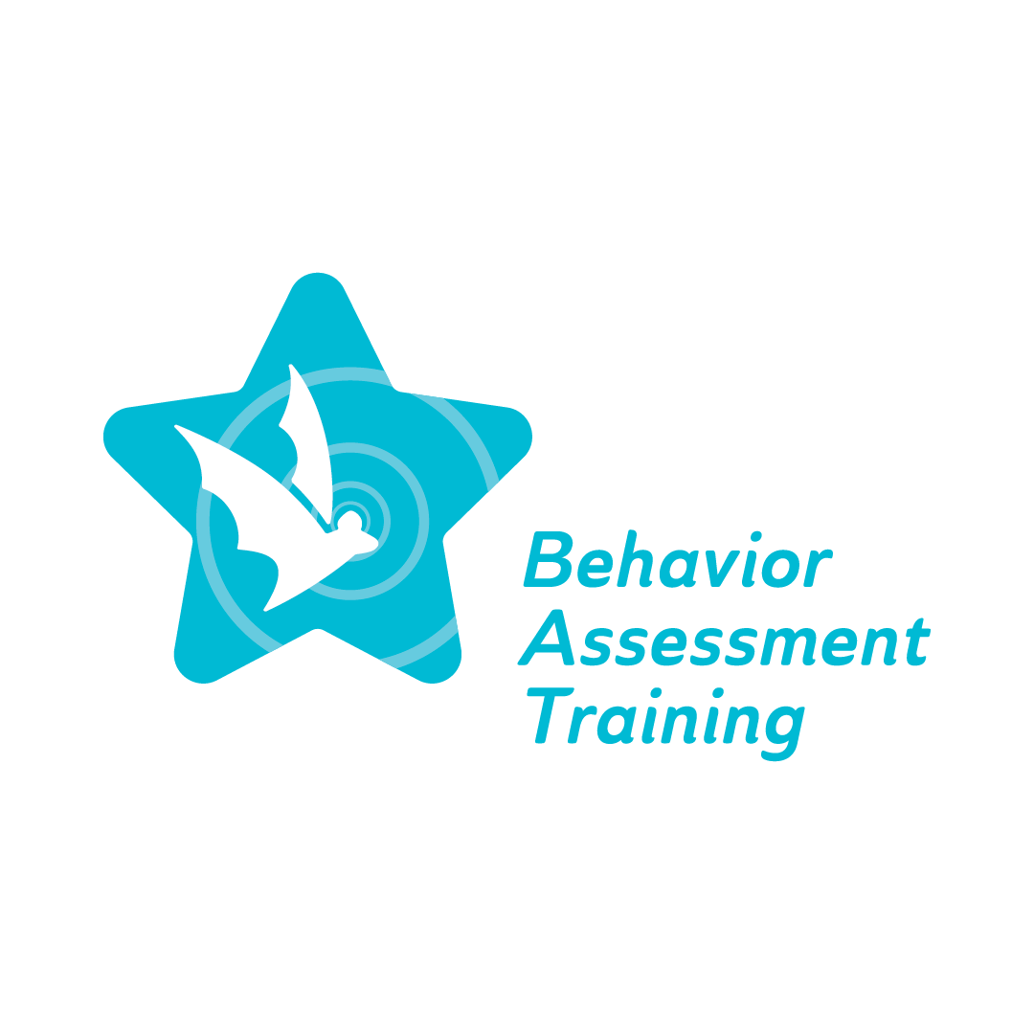
Fall 2022 Conference, Day 2, Session 1: K-12 Panel: Using a Behavior Lens to Examine Over-Representation (COVID, Cultural Differences, etc.)
Frequently Asked Questions (FAQ)

1. How has the pandemic impacted your students, families and/or district?
- How the SPED population saw some success during the return from the pandemic.
- Trust was built with parents.
- Having to reteach early elementary student's basic skills that they missed. Such as basic math skills, personal interaction, social skills (what is appropriate and what is not) and basic writing skills for both numbers and letters.
- More mental health issues for middle school age students. Early elementary students how to regulate emotions and have productive interaction with students their age.
- Students coming out of early intervention are showing huge deficits than ever.
- General education students are having the hardest time with social skills. A lot of general education students are frantic and acting out. SPED students have been actively taught how to self-regulate and negotiate change. The normal practice of self-regulation needs to be added into the gen ed classes at least until this population is through.
- Eye opening for a lot of staff about the circumstances some students faced daily.
- How the adults in the school were also affected by the pandemic.
- How the adults have also suffered from trauma related to the pandemic.
2. Have you/school/district noticed an increase in behavior related referrals, suspensions, and expulsions? If so, have you found over-representation within different sub-groups and how has your school/district addressed it (example: implemented MTSS (Multi-Tiered System of Supports) process to address specific areas of concerns)?
- SPED is not seeing an increase in behaviors. However, there is an increase in the number of referrals for students to enter the SPED/Alternative programs (grades 1-3; normally grades 4-6)
- The negative effects on the lower elementary students seem to be the most impactful.
- The success of the MTSS approach vs the RTI approach and that MTSS has been more successful after the pandemic. Seeing a shift of the “tiers” due to the increase of referrals.
- Increase of exclusionary discipline being used more with the “little” ones than ever before. Not what we want to see!
- Reaching out to the community for added help/counseling.
- A high turnover of staff and administration also affects the ability to supply the support and services needed by the entire student population.
- Importance of teaching what is expected about behaviors and “how to school” is most important. If that is taught, academics will come.
- Creating a safe space for teachers to ask for help and see that they do not know what to do next or about a specific issue.
3. How do you demonstrate respect and understanding for views on behavior that may differ from your own?
- Behavior is a form of communication!
- The student comes first!
- Possibly bringing in an unbiased opinion/observer.
4. What are some areas of your Student Code of Conduct that have been adopted/modified to reflect cultural responsiveness?
- It is not done well or addressed well.
- Bringing in community members/parents to create this. Make it more student focused and let them state their own ideas.
5. How does your district provide training on bias for the following school-based professionals: general educators, special educators, paraprofessionals, and related service providers? How has that impacted your professional practice?
- Not enough with little follow-up. Challenging with “everything” else going on.
- Left up to the individual teachers to seek out “training.”
- Nothing organized or “formal” training

