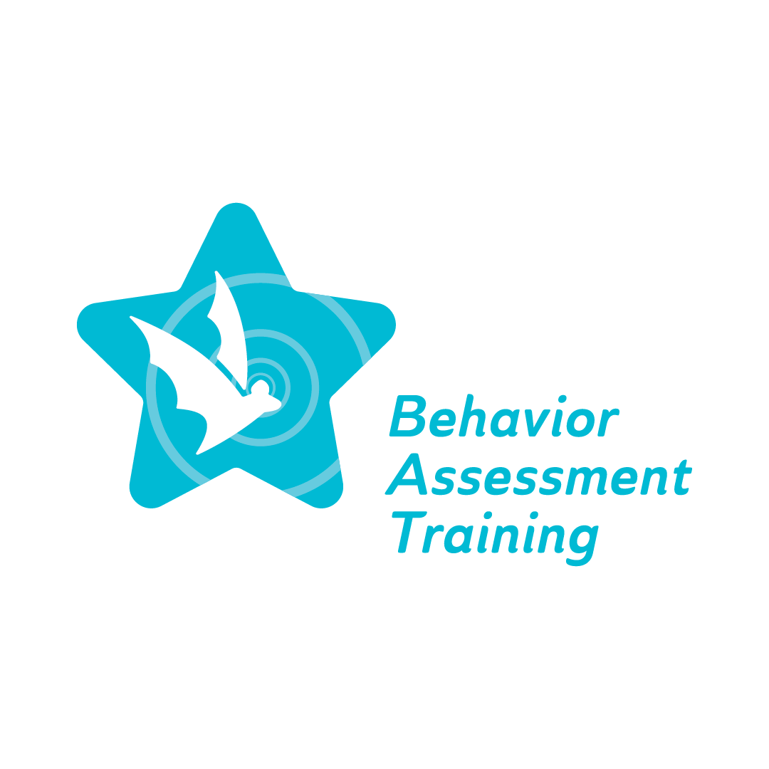
Topic 1, Part 1: Implicit bias and Stereotype Awareness:
Viewing student behavior through a personal lens
Frequently Asked Questions (FAQ)

- How do teachers demonstrate cultural responsiveness?
Be more aware and understand differences in culture and related characteristics including linguistics when working when diverse students. Be aware of cultural sensitivity. Create a classroom environment and instructional practices where students can add their input and knowledge of their background.
- Who is on the FBA team?
The team is led by a person trained in understanding behavior, such as a school psychologist, counselor, special education teacher or behavior specialist. The team should include the input of all school-based professionals who work directly with the student, the individual student, and their family.
- What can I do if I notice my coworkers and administrators at my schools are not culturally responsive in their disciplinary actions?
As described in the “What makes a good school culture” article, a ‘good school culture’ is cultivated when leaders communicate directly with teachers, administrators, counselors, and families, and when these individuals communicate openly and consistently. Members of a school organization should believe in and implement core beliefs and behaviors, such as collaboration, honesty, and hard work, within the classroom and throughout interactions with others.
Shafer, L. (2018). What makes a good school culture? https://www.gse.harvard.edu/news/uk/18/07/what-makes-good-school-culture
- How do I adapt my behavioral expectations to my students with IEPs in accordance with their abilities and the behavioral expectations they are experiencing at home?
As educators, we have high academic and behavioral expectations for our students. Clear expectations should be adapted and monitored, corresponding with each student's needs, abilities, and potential. Educators need to be aware that there may be a potential for mismatch in behavioral expectations of school-based professionals and those of a student’s family and/or community. When students are aware of and consistently reminded of behavioral expectations, they are more likely to follow these guidelines and develop an understanding of why they are being put into place.
- How can we, as educators, realize that we are unintentionally stereotyping/biased against students with colors that lead to punitive school discipline and associated negative outcomes?
Teachers must realize their biases and overcome them when working with students of color. According to the article “The persistent effect of race and the promise of alternatives to suspension in school discipline outcomes,” the author states that educators often view African American students as more aggressive, and it often affects the administrative decisions to disproportionally expel or suspend out-of-school. When compared to White students, whom the teacher perceives to appear “less aggressive” and engaging in the same infraction receives less punishment. The inconsistency of consequences between these decisions affects both students of color and white students.
Anyon, Y., Jenson, J. M., Altschul, I., Farrar, J., McQueen, J., Greer, E., ... & Simmons, J. (2014). The persistent effect of race and the promise of alternatives to suspension in school discipline outcomes. Children and Youth Services Review, 44, 379-386.

