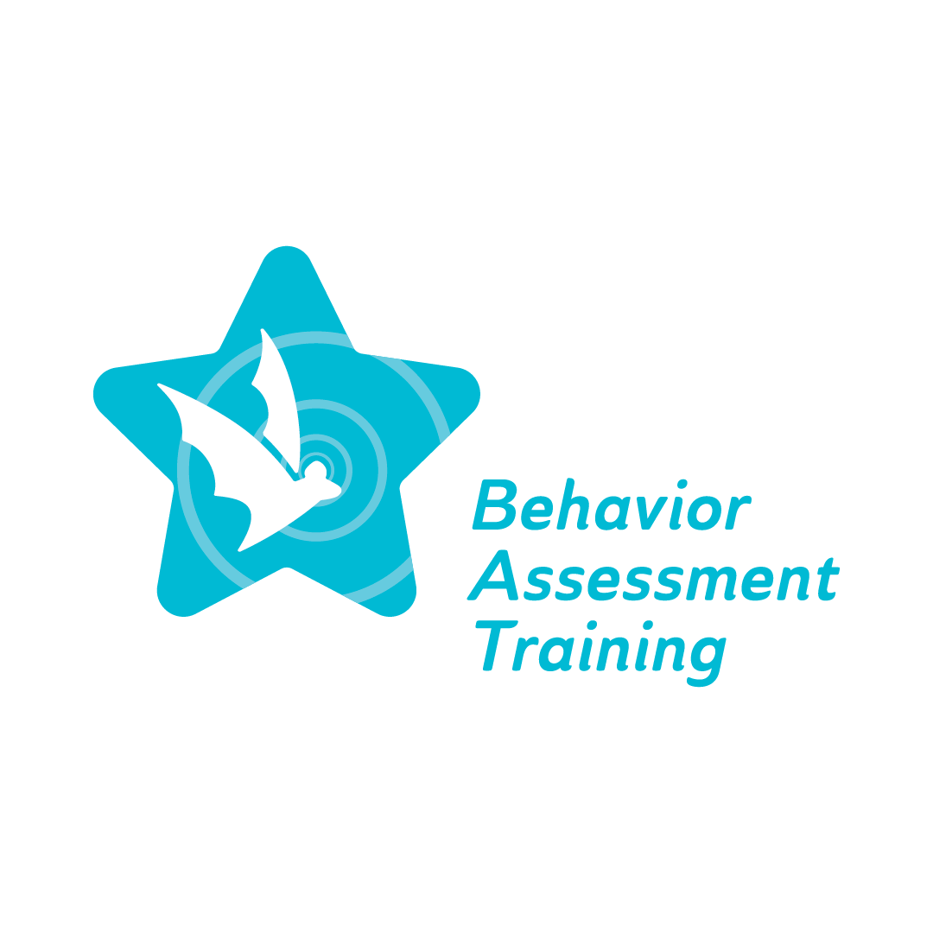
Fall 2022 Conference, Day 1, Session 3: Topic #2 Overview: Evidence-Based FBAs and BIPs
Frequently Asked Questions (FAQ)

- What is behavior in the school setting?
It is a repeated pattern of behavior or absence of behavior that impacts the students, their academic and emotional learning and their interactions with peers, staff, and teachers in the school setting, and their graduation rates and postsecondary success.
- What are some reasons for students to exhibit problem behaviors?
Students learn to perform a particular behavior to satisfy a need or result in the desired outcome. Some behavior problems come from a skilled deficit. Some behavior problems come with consequences of behavior.
- What is a skill deficit?
A skill deficit is when the student has not yet learned or does not have the necessary skill levels to perform the skill. For example, students diagnosed with Autism often exhibit skill deficits, such as not knowing how to carry a conversation, not understanding sarcasm, not recognizing facial gestures, etc.
- What is a performance deficit?
A performance deficit is where the student has the skill or knows how to perform the skill but does not perform it or does not perform to the acceptable level.
- What are some necessary questions when selecting target behaviors for intervention?
- Is the behavior disruptive, unusual, or high-level?
- Does the behavior impede socialization or acceptance from peers?
- Does the behavior obstruct learning, either academic or social?
- Will decreasing this behavior result in positive outcomes for the student?
- What should be avoided when writing a goal for students who exhibit behavioral difficulty in the school setting?
Vague terms: avoid terms like inappropriate/appropriate, rude, loud, polite, disrespectful. Avoid inconsistent expectations and unmeasurable terminology: understand, appreciate, analyze, evaluate, recognize.
- What are the steps in effective goal setting for students who exhibit behavioral difficulty?
- Antecedent: what comes directly before the behavior.
- Behavior
- Consequence: What comes right after the behavior.
- Reinforcement: Negative or Positive.
- What should be considered when trying to define a problem behavior?
Behaviors may be related to medications, medical condition, pain, discomfort, sleep, or other biological problems. The setting and situations/activities may need to be considered in defining a problem behavior. Emotions or behaviors may predict problem behaviors.
- How are consequences defined for a problem behavior?
- What happens when the problem behavior occurs?
- How do people react to the problem behavior?
- What does the behavior get for the child?
- What does the child escape from or avoid by engaging in the behavior?
- What are some questions when trying to define alternative behaviors for a problem behavior?
- What do you want the child to do instead of the problem?
- Would this desirable behavior displace the problem?
- Is the child capable of engaging in this behavior?
- What prevents this behavior from occurring?
- When a child exhibits multiple behaviors, which behavior should we focus on?
Look at the behavior that is most impactful of their time and that should be the behavior that we would target first. Some questions to keep in mind, such as what is the most disruptive to them when their body is hurting? What is the most disruptive to the classroom? Work with the big/challenging behavior first before working on improving a smaller/ less challenging behavior.
- Is behavior a communication method and would that be a deficit?
Yes, behavior is communication, and it can be improved by implementing different plans for the students to learn the skill.

