Bibliography 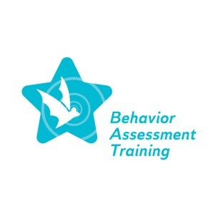
Topic 1

Ahram, R., Kramarczuk Voulgarides, C., & Cruz, R. A. (2021). Understanding disability: High- quality evidence in research on special education disproportionality. Review of Research in Education, 45(1), 311-345.
Allman, K. L., & Slate, J. R. (2013). Disciplinary consequences assigned to students with emotional disorders, learning disability or other health impairment: Effects on their academic achievement. Journal of Education Research, 7(1), 83-101.
Annamma, S. A., Handy, T., Miller, A. L., & Jackson, E. (2020). Animating discipline disparities through debilitating practices: Girls of color and inequitable classroom interactions. Teachers College Record, 122(5), 1-46.
Anyon, Y., Jenson, J. M., Altschul, I., Farrar, J., McQueen, J., Greer, E., ... & Simmons, J. (2014). The persistent effect of race and the promise of alternatives to suspension in school discipline outcomes. Children and Youth Services Review, 44, 379-386.
Elmore, R. F. (2005, June). Accountable leadership. The Educational Forum, 69(2), 134-142.
Fenning, P. A., & Johnson, M. B. (Eds.). (2022). Discipline disparities among students with disabilities: Creating equitable environments. Teachers College Press.
Goldstein, S. E., & Brooks, R. B. (2007). Understanding and managing children's classroom behavior: Creating sustainable, resilient classrooms. John Wiley & Sons, Inc.
Hettleman, K. R. (2019). Mislabeled as disabled: The educational abuse of struggling learners and how we can fight it. Radius Book Group.
Tralli, R. (2022). Irrefutable influence: The impact of school culture on student intervention success. Council for Exceptional Children.
Shafer, L. (2018). What makes a good school culture? https://www.gse.harvard.edu/news/uk/18/07/what-makes-good-school-culture

