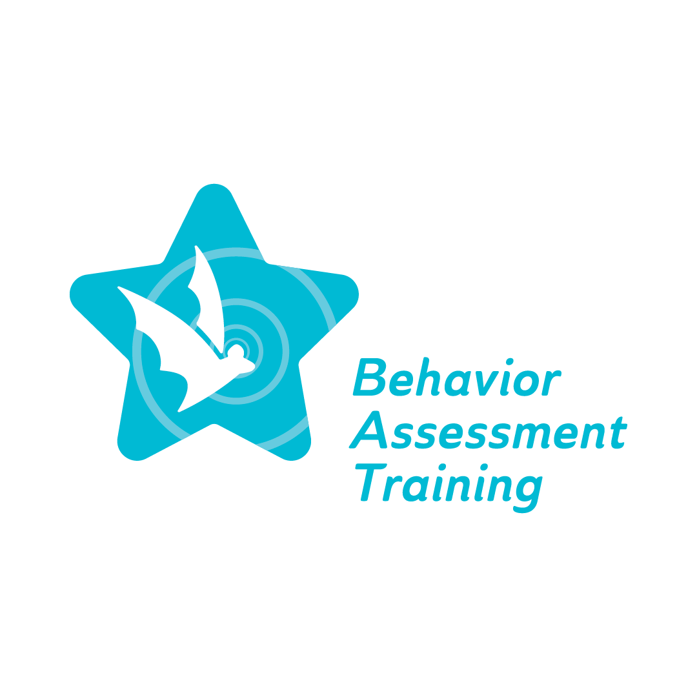
Topic 1, Parts 1- 4: Implicit bias
Glossary of Terms
Behavioral expectations - broad goals and/or general ways teachers would like students to act; guidelines for behavior for all students across all settings.
BIP - BIP is the abbreviation for Behavior Intervention Plan. The IEP team, including educators, school-based professionals, families, the individual student, and school administrators, create this plan after the FBA is completed and is comprised of strategies, methods, and interventions to reduce challenging behavior and increase appropriate replacement behavior.
Cultural responsiveness - ability to understand cultural differences through self-evaluation and learning to realize your own biases, respond respectfully to differences, and work with children, families, and communities to identify and focus on commonalities and respect differences.
Direct assessment – data collected by directing observing a student in different settings.
Enacted values - represents personal true beliefs
Entrenched norms - the gap between espoused and enacted values which can impact students, school professionals, and the community.
Espoused values - values held by school administration/organizational leadership team.
FBA - FBA is the abbreviation for Functional Behavioral Assessment. Educators, school-based professionals, and school administrators use this assessment to determine the cause of a student's challenging behavior and devise a solution.
Implicit bias – a form of bias that occurs unintentionally or unconsciously that affects judgments, decisions and behaviors toward others.
Indirect assessment – data collected by reviewing records and interviewing educators, school-based professionals, families, and the student.
Positive reinforcement – providing a desired stimulus (e.g., praise, preferred activity, etc.) after a behavior.

School climate – school conditions including engagement, safety and environment.
School culture – reflects core values, strategic plans, reflective practice, accountability, and leadership.
Social validity - a behavioral concept that refers to the social significance of intervention goals, social acceptability of intervention procedures, and the social importance of their effects.
Stereotyping - widely held, fixed and oversimplified image or idea of a particular type of person (e.g., race, geographic location).
Teacher bias - one or more factors that influence or cause a teacher to have higher expectations for some students and lower expectations for others; this situation often creates results to match the expectations.

